**Template for Activity combining Mechanism Kit and TinkerCAD**

**Task I:**

**Design Catapult on TinkerCAD**

**Task 2**

**Assemble the same using components available in Mechanism kit**

**Evaluation Criteria:**

1. **Photos of TinkerCAD Model ( Stage wise)**
2. **Video of Final working Model**
3. **Photo of Component Assembly**
4. **Reflection on the Activity**

**Performance-15 Marks : Basic Model = 5 marks , Demonstration of Working = 5 marks, 3 D Model using TinkerCAD = 5 marks**

**Submission-10 Marks**

**Team**

|  |  |  |  |
| --- | --- | --- | --- |
| **Sr No** | **Roll No** | **Name** | **Work Done** |
| 1 | 16010123011 | Aaryan Dubey | TinkerCAD Model |
| 2 | 16010123012 | Aaryan Sharma | TinkerCAD Model |
| 3 | 16010123013 | Aayush Hardas | Working Model |
| 4 | 16010123014 | Aayush Sawant | Working Model |
| 5 | 16010123015 | Abdullah Qureshi | Working Model |

Photo of TinkerCAD model

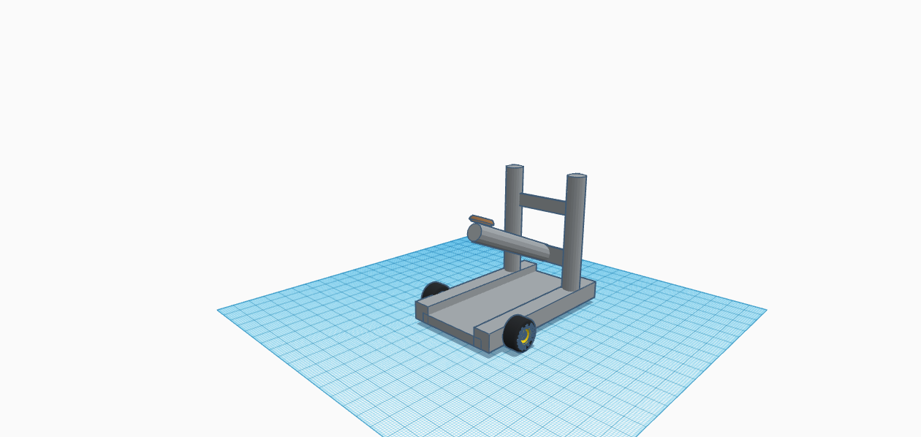

**Video of Working Model**

[**https://drive.google.com/drive/folders/15u4x2oHidEkRxRdqeg29PdS4P2IM3Nfg**](https://drive.google.com/drive/folders/15u4x2oHidEkRxRdqeg29PdS4P2IM3Nfg)

**Reflection of Activity**

Designing a catapult in Tinkercad and building a working model is an excellent hands-on activity. It helps students in practical applications. Thinking and using their creativity students needed to plan, create, test, and iterate their designs, promoting problem-solving skills. Building a working catapult involves understanding basic mechanical principles such as leverage, tension, and release. This practical application reinforces theoretical knowledge. The design process encourages creativity and innovation as students experiment with different shapes, sizes, and mechanisms to optimize the catapult's performance and design. Tinkercad helps in digital design skills, providing an introduction to 3D modeling and virtual prototyping, which are valuable skills. Translating a virtual design into a physical working model bridges the gap between the digital and physical worlds, reinforcing the idea that designs can be tangible and functional. Collaborative projects, where students or participants work together to design and build catapults, promote teamwork and communication skills.

The catapult project demonstrates how theoretical concepts learned in the classroom have real-world applications. It connects abstract principles with tangible outcomes.

In summary, creating a catapult in Tinkercad and building a working model is a multifaceted activity that combines digital design skills with practical application, , problem-solving, and creativity.